**Community Engagement Fellowship – Final Report**

*Photo: Sampling equipment in Ellerbe Creek, Durham, NC*

**Title: Using a Novel Approach to Studying Water Quality in an Urban River**

**Author: Kriddie Whitmore**

**Summary**

In this project I characterized select parameters of water quality within Ellerbe Creek, an urban river draining the city of Durham, NC. I used a novel technique of collecting Nitrate concentration in-*situ* at high spatial resolution from river headwaters to out flow in Jordan lake. Though urban infrastructure is spatially variable, I found the overwhelming driver of water quality change to be the water treatment plant approximately 4.75 miles upstream of Falls Lake, downstream of dense urban development. This finding suggests that efforts to reduce nitrogen loading into Falls Lake should emphasize the treatment of nitrogen below the water treatment plant. This study successfully demonstrates that using sensor technology to collect synoptic data, through space rather than through time, could be used as an effective and compelling way to demonstrate changes in water chemistry in a river system. If further developed, the methods detailed in this report may be a viable way for community organizations to evaluate water quality in nearby water bodies.

**Introduction**

Urban runoff is a leading source of water quality degradation in surface waters of the United States (USEPA 2002). Urbanization causes a suite of changes to the hydrology, chemistry, and biology of the receiving river system. Conversion of watershed land to impervious surfaces and expansion of stormwater infrastructure drives increases in nutrient loading, flashiness of the river hydrograph, and total suspended solids (Walsh et al., 2005). Nutrient pollution, particularly in the form of inorganic nitrogen, has degraded freshwater and estuary ecosystems by stimulating algae blooms that lead to anoxic zones and fish kills. Excess nitrogen may reach toxic levels, stressing aquatic organisms and decreasing the quality of drinking water. As a result, nitrogen pollution has a significant impact, directly and indirectly, to human health and the economy (Bernhardt et al., 2008; Camargo & Alonso 2006).

In urban settings, excess nitrogen enters the environment through human activities including the addition of lawn fertilizers, automobile emissions, and mismanagement of wastewater. (Carpenter et al., 1998). Studies have found population density and urbanization to be drivers of nitrogen loading (Hatt et al., 2004; Peierls et al., 1991; Cole et al., 1993) and cities to be hotspots of nitrogen pollution (Zhang et al., 2015). However, clear connection between nitrogen loading and land-use does not always bare out in research (Novotny & Olem 1994; Hatt et al. 2005; Brezonik & Stadelmann 2002). Connection between specific land-use variables and nitrogen loading is needed to inform city planners and water resources managers as they strike a balance between development and water quality.

Studies have identified various urban landscape features that may drive nitrogen loading. Nitrogen loading has been associated with increased connectivity between runoff and rivers due to stormwater infrastructure and roadways (Wollheim et al., 2005). Roads themselves have been cited as sources of nitrogen pollution (Hatt et al., 2002). Studies have also observed septic systems to have a strong relationship with nitrogen concentrations (Hatt et al. 2005; Bernhardt et al., 2008). On the flip side, riparian greenways and constructed wetlands have been found to reduce nitrogen loading (Batbayar et al. 2019; Vymazal 2011).

Though it is well established that urbanization has profound impacts on a river’s ecosystem services, the relationship between nitrogen loading and specific elements of the urban landscape is not well defined. The complexity of the urban landscapes translates to a complexity and large spatial variance of water quality in urban rivers. In this study I employed a novel approach for evaluating nitrogen pollution by using advanced sensor technology to collect data at high spatial resolution. Increased resolution of data may allow researchers to tease apart the factors driving water chemistry changes. The primary goal of this study was to identify the major drivers of increase and decrease in nitrate concentrations within an urban river. In this project, I will examine the relationship between urban infrastructure and water quality by asking the question, how does urban land use and infrastructure in a watershed influence nitrogen pollution in rivers?

**Methods**

*Study Site*

Ellerbe Creek is the mainstem of an urbanized river network draining downtown Durham and high-density residential neighborhoods (Fig 1). The river flows into Falls Lake, a major source of drinking water for Durham and Raleigh residents. Ellerbe Creek is an ideal study system as it is local, highly urbanized, and listed as an impaired river by the EPA. As such, the City of Durham is obligated to reduce the nitrogen load delivered to Falls Lake. In addition, Durham County’s population is expanding at a rapid pace. Land development is also expanding to keep up with the city’s growth so the need for science-based policy regarding development’s impact on water quality is immediate.

*Instrumentation*

In the fall of 2021, October 21st – 22nd, I conducted a highly spatially resolved sampling of Ellerbe Creek from headwaters to the outflow, a distance of 19 km. A suite of variables was measured. Nitrate, the most abundant form of nitrogen, was sampled with a spectrometer probe, spectro::lyzer V3 (S::CAN, Vienna, Austria) capable of collecting in-situ measurements of nitrogen concentration as rapidly as 1 reading per minute. The S::CAN allowed me to collect highly spatially resolved data at minimal cost. The S::CAN was fitted to a flotation device constructed of 2 PVC pontoons. The instrument was pushed upstream through the river so that it remained upstream of disturbed sediments. The floatation device ensured that data was collected at a consistent depth. At some locations the river became un-wadable, or too shallow to collect data. At these locations, the instrument was lifted out of the water and moved upstream. Geolocation of each sample was collected using a GPS unit, etrex 20 (Garmin, Olathe, KS), programed to record location every 15 seconds. To calibrate the S::CAN, water chemistry samples were collected at even intervals throughout the study reach.

*Fig 1.*

Fig 1. Map of Ellerbe Creek within Durham County, NC. Ellerbe Creek watershed is delineated in black. Land Cover/Land Use is a dataset derived from Landsat imagery by United States Geological Survey

*Water samples*

Water samples were collected at even interval throughout the study reach to calibrate the spectrometer instrument. We filtered water samples in the field through 0.4 um polyethylene Millipore filters directly into acid-washed PTFE 60 mL bottles. Samples were stored on ice in a cooler until they were transported back to the lab and frozen at − 20 °C. We analyzed all stream water samples in the laboratory for major anion concentrations (NO3−-N, Cl−, Br−, SO42−; mg/L) on a Dionex ICS-2000 ion chromatograph with an AS40 autosampler on an IonPac AS-18 analytical column and guard (Dionex Corp., Sunnyvale, CA). We measured dissolved organic nitrogen (DOC) total dissolved nitrogen (TDN) concentrations (mg/L) with a Shimadzu TOC-VCPH with TNM-1 module (Shimadzu Corp., Kyoto, Japan). This study will report on findings from Nitrate and DOC.

*S::CAN Calibration*

The spectrometer instrument was calibrated for Nitrate and Dissolved Organic Carbon using 20 water samples collected throughout the stream reach. Due to the pronounced effect of the inflow of a water treatment plant on the water chemical matrix, I found it necessary to create a separate calibration above and below the water treatment plant. DOC was based on a strong linear relationship between DOC water samples and 300µm wavelength. Because DOC is known to interfere with nitrate wavelengths, nitrate was calibrated based on a linear relationship between Nitrate in water chemical samples and an equation developed in Edwards et al (2001) that utilized wavelengths, 300µm and 205µm.

**Results**

Below I describe findings for two water quality parameters, nitrate and dissolved organic carbon (DOC). As described above, nitrate is of primary interest as a widespread pollutant in freshwater systems. DOC is also reported, as it is strongly linked to CO2, a greenhouse gas, outgassing from rivers (Battin et al. 2008).

The data collected over the course of this study tells a compelling and quite simple story. There is a dramatic increase in nitrate (figure 2) and DOC (figure 3) concentrations at the outflow of a water treatment plant that treats the majority of wastewater produced by the city of Durham. Water samples collected effectively demonstrate this point, but the story in strengthened by the calibrated sensor output. In addition, there is a distinct, stepwise change in the spectral signature of DOC below the treatment plant, indicating that the major source of DOC changes from up to downstream of the outflow. I found that small variation in nitrate concentrations were completely overwhelmed by the singular input of Durham wastewater, limiting my ability to assess changes in nitrate due to other factors such as riparian buffers.

*Figure 2.*

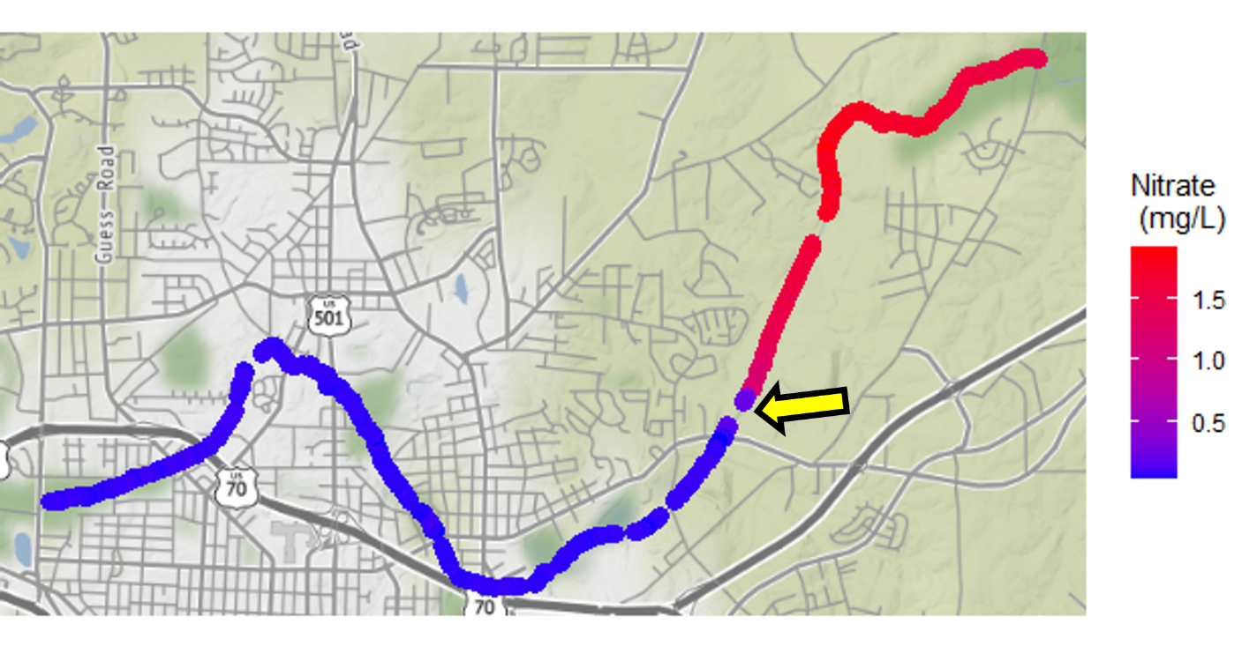

Figure 2. Nitrate concentrations in Ellerbe Creek, Durham NC. Samples were collected in October 21 – 22, 2021. The yellow arrow indicated the location of a water treatment plant outflow.

*Figure 3.*

Figure 3. Dissolved organic carbon concentrations in Ellerbe Creek, Durham NC. Samples were collected in October 21 – 22, 2021. The yellow arrow indicated the location of a water treatment plant outflow.

*Future work*

This data set provides strong support for the potential for this methodology to provide much needed information about the drivers of water quality change in a stream. With additional work dedicated to improving the calibration of the sensor, I believe I will be able to identify secondary drivers of nitrate concentrations, useful to local municipalities and community organizations. In addition, I believe this technology could be used to identify point sources of contamination less obvious than water treatment plant outflows, such as sewer leaks or illegal dumping.

Though sensor technology used in this study would represent a large, potentially prohibitive, cost to a small community group, once the instrument is purchased, the time and money needed to collect a large data set is minimal. I believe there is potential for academic labs who have already purchased this equipment to conduct studies as a way to rapidly evaluate issues of water quality in rivers that are of concern to a community.

*Community Partner*

I worked in collaboration with Ellerbe Creek Watershed Association. Through the course of this project, I attended Water Management Board meetings where I learned about the priorities of ECWA in connecting the Durham community to Ellerbe Creek. I plan to present my preliminary findings next month.

**Works Cited:**

Batbayar, G., Pfeiffer, M., Kappas, M., & Karthe, D. (2019). Development and application of GIS-based assessment of land-use impacts on water quality: A case study of the Kharaa River Basin. *Ambio*, *48*(10), 1154-1168.

Battin, T. J., Kaplan, L. A., Findlay, S., Hopkinson, C. S., Marti, E., Packman, A. I., ... & Sabater, F. (2008). Biophysical controls on organic carbon fluxes in fluvial networks. Nature geoscience, 1(2), 95-100.

Brezonik, P. L., & Stadelmann, T. H. (2002). Analysis and predictive models of stormwater runoff volumes, loads, and pollutant concentrations from watersheds in the Twin Cities metropolitan area, Minnesota, USA. *Water research*, *36*(7), 1743-1757.

Carpenter, S. R., Caraco, N. F., Correll, D. L., Howarth, R. W., Sharpley, A. N., & Smith, V. H. (1998). Nonpoint pollution of surface waters with phosphorus and nitrogen. *Ecological applications*, *8*(3), 559-568.

Cole, J. J., Peierls, B. L., Caraco, N. F., & Pace, M. L. (1993). Nitrogen loading of rivers as a human-driven process. In *Humans as components of ecosystems* (pp. 141-157). Springer, New York, NY.

Edwards, A. C., Hooda, P. S., & Cook, Y. (2001). Determination of nitrate in water containing dissolved organic carbon by ultraviolet spectroscopy. International Journal of Environmental Analytical Chemistry, 80(1), 49-59.

Hatt, B. E., Fletcher, T. D., Walsh, C. J., & Taylor, S. L. (2004). The influence of urban density and drainage infrastructure on the concentrations and loads of pollutants in small streams. *Environmental management*, *34*(1), 112-124.

Peierls, B. L., Caraco, N. F., Pace, M. L., & Cole, J. J. (1991). Human influence on river nitrogen. *Nature*, *350*(6317), 386-387.

Yang, Y. Y., & Toor, G. S. (2017). Sources and mechanisms of nitrate and orthophosphate transport in urban stormwater runoff from residential catchments. Water Research, 112, 176-184.

Vymazal J (2011) Constructed wetlands for wastewater treatment: five decades of experience. Environ Sci Technol 45:61–69

Walsh, C. J., Roy, A. H., Feminella, J. W., Cottingham, P. D., Groffman, P. M., & Morgan, R. P. (2005). The urban stream syndrome: current knowledge and the search for a cure. *Journal of the North American Benthological Society*, *24*(3), 706-723.

Wollheim, W.M., B.A. Pellerin, C.J. Vorosmarty & C.S. Hopkinson. 2005. N retention in urbanizing headwater catchments. Ecosystems 8: 871–884.

USEPA. 2002. 2000 National Water Quality Inventory. U.S. Environmental Protection Agency, Office of Water. Washington , DC .

Zhang, X., Wu, Y., & Gu, B. (2015). Urban rivers as hotspots of regional nitrogen pollution. Environmental Pollution, 205, 139-144.